Lobos Character Description

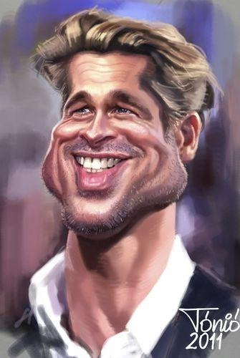
Diego
The sexiest man on earth, masculine and strong personality on the red carpet. Behind the scenes a sensitive flower that believes in true love... himself.
His entourage carries his expensive oil portraits, fragrances and extra mirrors.
You must reassure his perfection or he will snap at you.

Prospects -
Rafael de la Fuente (Venezuela)

Pati Le Pu
The sensual rabbits girl in the red dress.
Like a good movie star she seduces with cinematic gestures. Classy and fancy until she has a drink to reveal a street girl from tha hood. She is an alcoholic.
She pretends wealth and high status, but desperately wants a husband before hitting her fifties.
If you pay attention to her cloths you might see some holes.
Her entourage consists of the eldest team of agents and managers. They might seem harmless, weak and slow, but they are very wise on how to destroy a person's reputation.

Prospects -
Patricia Velasquez (Venezolana)
Patricia de Leon (Panamá)
Carla Ortiz (Bolivia)
Patricia Maya (Mexico)

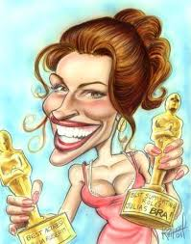

Kate
The only real actress that graduated from the best acting drama school in the world. She can cry in command and that is her lethal weapon. She works on her craft evey second of the day.
She is the only one that has a brain and surrounds herself with a professional hairstylist, makeup artist and dresser. The poor souls are exhausted and have been physically and verbally abused by the diva.
She only wants the award because it will give her the status
to become a politician.
She regards her peers as insignificant creatures.
Where ever she steps her paid photographers snap.

Prospects -
Paz Vega (Spain)

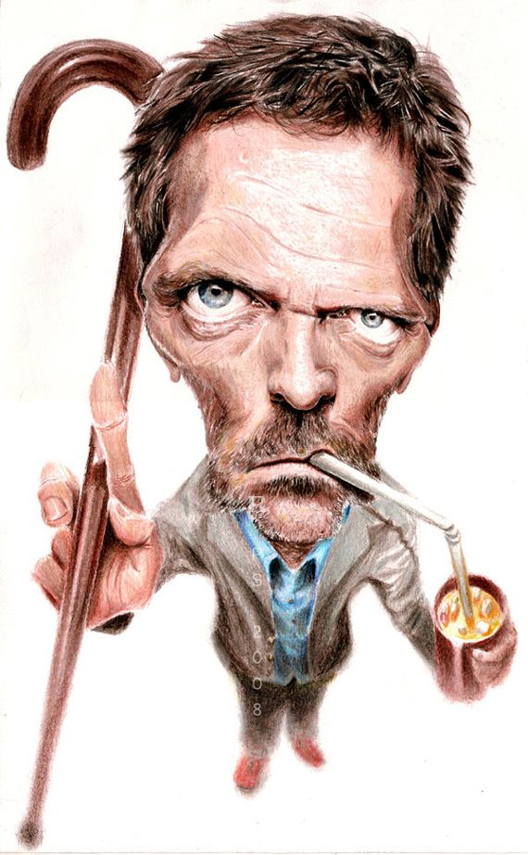

Antonio Miguel
A true actor from the stage. Because he has done hundreds of plays he has developed a psychological problem becoming multiple characters at any time.
He has been diagnosed with multiple personalities. He is a genius on screen but a mess in the public. He might creep you out.
His manager and agent are doctors that test different pills in dramatic situations to bring him back to his movie star persona.
Every time we see Marcelo he is a different human being.

Prospects -
Eugenio Derbez (Mexico
Oscar Jaenada (Mexico)

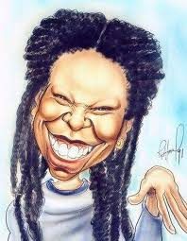

Celia Cecilia alias la Venenosa
A talented actress and curandera. She has the ability to read people, feel bad energies and talk to some spirits.
If she likes you she might give you a spiritual cleanse, if not a santera curse.
She travels with her mother and ugly sister twins. They all want a prince.
Prospects
Yordanka Arioza (Cuba)
Jeimy Osorio (Puerto Rico)

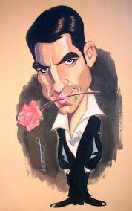

Leonardo Guillermo
A romantic sex addict. His incredible charisma matches his dumbness. Sings like an angel.
He travels with his gay publicist and his fabulous assistants.
His team is about to get fired by an angry agent who constantly calls threatening. They must keep the movie star out of trouble in a final effort to save his horrible image.
Prospects
Reynaldo Pacheco (Bolivia)

Mia Paloma
A disney princess until she gets mad and she might kill you. A lethal warrior in all the martial arts.
Loves flowers, music and pets. Therefore her entourage follows her around with fun ornaments and music.
She was blessed with a special ability to communicate with animals.
She was trained in musical Theatre.
She is madly in love with Diego but she is definitely not a virgin, there the prince Diego will never be with her.

Prospects
Celines Toribio ( Republica Dominicana)

Anastasia
A telenovela star. She can seduce anything that moves, even Ricardo.
Obsessed with being fit, young and perfect.
She is very outspoken and honest. She is so real that most people despise her.
She talks dirty to her millions of followers.
She is always exercising.

Prospects
kate del Castillo ( Mexico)
Angie Cepeda (Mexico)
Paz Vega (Spain)
Carla Ortiz (Bolivia)

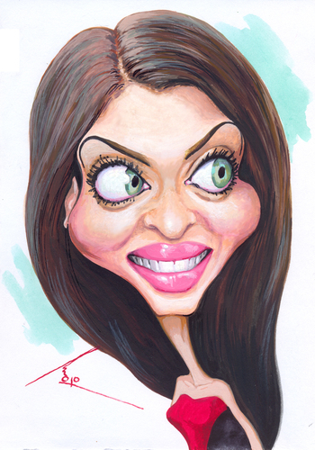
Mariquita
Insecure and afraid of everything, even her own shadow.
Her acting coach suffers post traumatic stress disorder. She really tries to make her learn lines and study at this peak moment of her career.
Mariquita lost her memory when she was a baby, she fell from the cradle.
She can’t escape her fans, photographers, bloggers, stalkers and social media influencers. Definitely the most famous yet the least talented…. Yes her acting is the worst.
She has the gift of being wrapped in the most traumatic situations with stalkers and yellow press.

Prospect
Monica Huarte (Mexico)

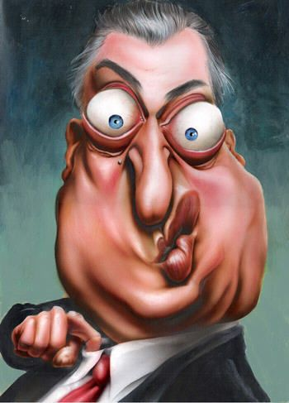

Tim Taylor

The oldest man in this business.
He is a producer more than an actor therefore everybody loves him. However he suffers from “Automysophobia” the fear of being dirty. His entourage protect him from germs and help him in his excessive cleaning
While everybody wants to be his “friend” He suffers from extreme anxiety, dread and anything associated with panic such as shortness of breath, rapid breathing, irregular heartbeat, sweating, excessive sweating, nausea, dry mouth, nausea, inability to articulate words or sentences, dry mouth and shaking.

Prospect
Ricardo Darin (Argentina)
Ken Davitian (

Note - Every star has employees that follow them with a camera for their live social media shows.

La Tutora Nigma
Edward

